Chapter 3: Hands-On Cryptography with Python requires installing and configuring Windows systems as follows:

Ensure Path contains: c:\Python27\scripts\;c:\Python27   
  
Verify pip   
pip --version  
  
Download Microsoft Visual C++ Compiler for Python 2.7  
<https://www.microsoft.com/en-us/download/confirmation.aspx?id=44266>

run the VCForpython27.msi to install, double clicking downloaded MSI file

Padding Oracle Attack

Download pycrypto 2.6.1  
<https://pypi.org/project/pycrypto/#description>

Install package at the command prompt by typing **pip install pycrypto**

RSA implementation in Python

Download

<https://pypi.org/project/rsa/#files>

Install package at the command prompt by typing **pip install rsa**

Chapter 3: Hands-On Cryptography with Python has errors in the screenshots, refer to the below:

CBC

Page 65 correct screenshots

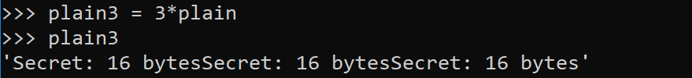



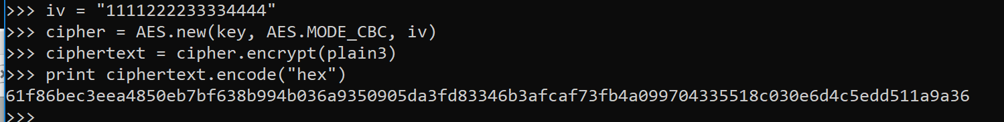

Padding Oracle Attack screenshot corrections

Page 68 step 2 and 4

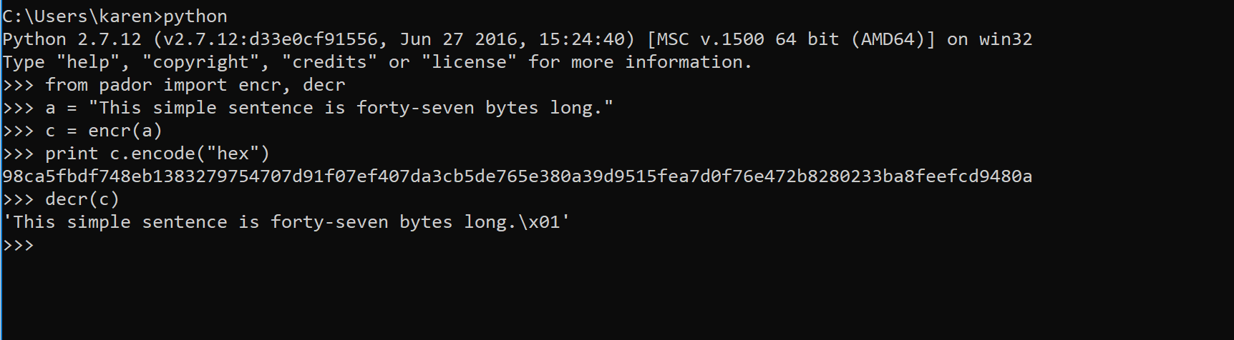

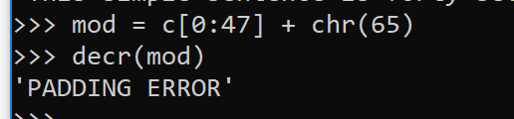

Page 70

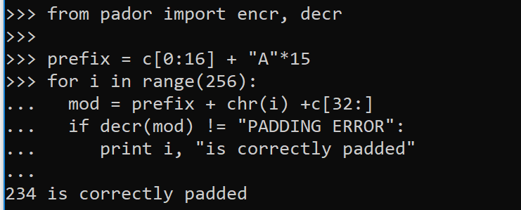

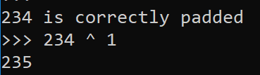

Page 71

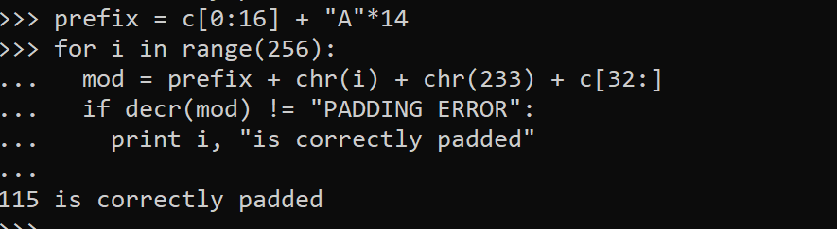

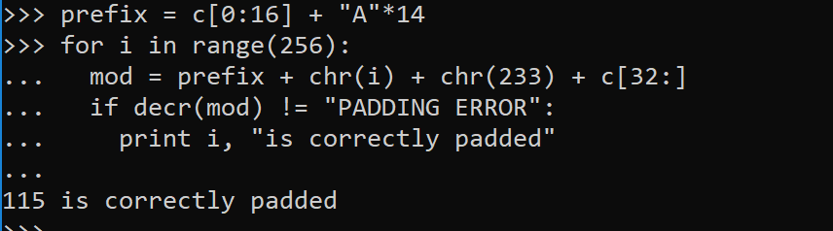

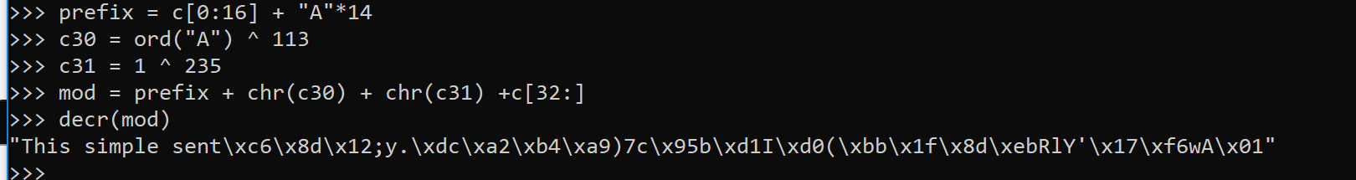

RSA page 77

>>> plain = 'encrypt this messagf'

>>> ciphertext = publickey.encrypt(plain, 0)[0]



>>> print ciphertext.encode("hex")

